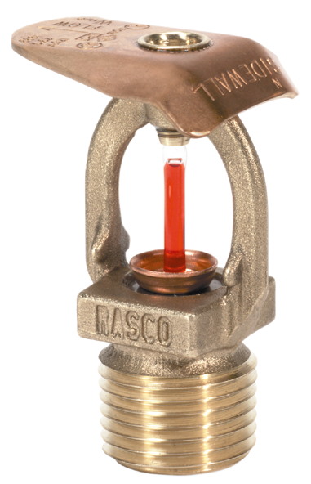

Engineering Specification
Model F1FR Quick Response
Sidewall Sprinklers

Sprinklers shall be standard coverage, quick response [horizontal sidewall] [recessed horizontal sidewall] [vertical sidewall] sprinklers that are [cULus Listed][FM Approved [NYC MEA Approved – 258-93-E] for light hazard occupancies. Sprinkler frame and deflector shall be of bronze frame construction having a [½”][ ¾”] NPT thread. Water seal assembly shall consist of a Teflon-coated Belleville spring washer and top-loaded extruded cup with 3 mm glass bulb containing no plastic parts. Sprinkler temperature rating shall be [135 °F (57 °C)] [155 °F (68 °C)] [175 °F (79 °C)] [200°F (93°C)] [286 °F (141 °C)]. Sprinklers shall have a nominal K-factor of 5.6 (81.0) – standard orifice. Sidewall Sprinklers shall have a rated working pressure of 175 psi (12.1 bar). [The vertical sidewall shall be installed in the [upright] [pendent] position. Standard finish: [Bronze] [Chrome-plated] [Special finish– specify]. Sprinklers shall be Reliable Model F1FR [horizontal sidewall – SIN R3635] [vertical sidewall – SIN R3685], Bulletin 136.

Escutcheon Options

Model F2 escutcheon (horizontal sidewall only)

Recessed escutcheon assembly shall be a steel, two-piece, friction-fit escutcheon with 1/2” adjustment. Standard finish shall be [brass][bright chrome] [white painted].

